Working Standards
# Source: AI Source: Provided by: [Data Path: Persons Table -> ID Column: 1, Name_En Column: Motasem Essam] -> From: [ChatGPT] on [7/17/2026]
Working Standards are measurement standards that are used routinely for the calibration of measuring instruments and for everyday measurement activities. They are calibrated against reference standards (or, in some cases, secondary standards) and provide the practical measurement reference used in laboratories, industries, workshops, and testing facilities.
Working standards are the lowest level in the hierarchy of measurement standards, but they are the most frequently used.

Definition
# Source: AI Source: Provided by: [Data Path: Persons Table -> ID Column: 1, Name_En Column: Motasem Essam] -> From: [ChatGPT] on [7/17/2026]
A Working Standard is a measurement standard used regularly for the calibration, verification, and adjustment of measuring instruments during routine measurement activities.
Its value is established by calibration against a reference standard, ensuring traceability to higher-level standards.

Purpose
# Source: AI Source: Provided by: [Data Path: Persons Table -> ID Column: 1, Name_En Column: Motasem Essam] -> From: [ChatGPT] on [7/17/2026]
Working standards are used to:
- Calibrate measuring instruments.
- Verify instrument accuracy.
- Perform routine laboratory measurements.
- Support industrial quality control.
- Maintain measurement consistency.
- Provide traceability for everyday measurements.

Characteristics
# Source: AI Source: Provided by: [Data Path: Persons Table -> ID Column: 1, Name_En Column: Motasem Essam] -> From: [ChatGPT] on [7/17/2026]
Working standards are:
- Accurate enough for routine measurements.
- Used frequently.
- Calibrated against reference standards.
- Periodically recalibrated.
- Easier to handle than higher-level standards.
- Maintained according to laboratory quality procedures.

Position in the Measurement Hierarchy
# Source: AI Source: Provided by: [Data Path: Persons Table -> ID Column: 1, Name_En Column: Motasem Essam] -> From: [ChatGPT] on [7/17/2026]
Working standards occupy the lowest level among measurement standards.
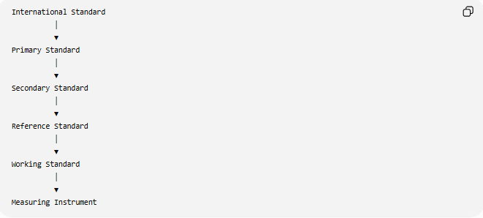
International Standard
│
▼
Primary Standard
│
▼
Secondary Standard
│
▼
Reference Standard
│
▼
Working Standard
│
▼
Measuring Instrument

How Working Standards Are Established
# Source: AI Source: Provided by: [Data Path: Persons Table -> ID Column: 1, Name_En Column: Motasem Essam] -> From: [ChatGPT] on [7/17/2026]
A working standard is calibrated using a reference standard.
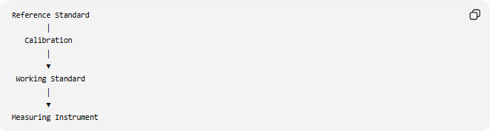
Reference Standard
│
Calibration
│
▼
Working Standard
│
▼
Measuring Instrument

Functions of Working Standards
# Source: AI Source: Provided by: [Data Path: Persons Table -> ID Column: 1, Name_En Column: Motasem Essam] -> From: [ChatGPT] on [7/17/2026]
Working standards are used to:
- Calibrate measuring instruments.
- Verify instrument performance.
- Perform routine laboratory calibration.
- Support production quality control.
- Maintain measurement consistency in daily operations.
- Provide traceable measurements.

Examples of Working Standards
# Source: AI Source: Provided by: [Data Path: Persons Table -> ID Column: 1, Name_En Column: Motasem Essam] -> From: [ChatGPT] on [7/17/2026]
Length
- Steel ruler certified against a reference standard.
- Precision caliper used for routine calibration.
- Working gauge blocks.

Mass
- Laboratory calibration weights used to verify balances.
- Standard test weights used in industrial scales.

Temperature
- Laboratory thermometer used for routine calibration.
- Industrial temperature calibrator.

Pressure
- Working pressure gauge.
- Portable pressure calibrator.

Electrical Measurements
- Working digital multimeter.
- Portable voltage calibrator.
- Current calibration source.

Time
- Laboratory stopwatch verified against a reference clock.
- Working frequency generator.

Traceability
# Source: AI Source: Provided by: [Data Path: Persons Table -> ID Column: 1, Name_En Column: Motasem Essam] -> From: [ChatGPT] on [7/17/2026]
Working standards maintain traceability through reference standards.
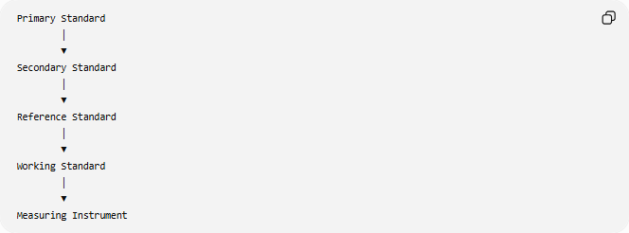
Primary Standard
│
▼
Secondary Standard
│
▼
Reference Standard
│
▼
Working Standard
│
▼
Measuring Instrument

Calibration
# Source: AI Source: Provided by: [Data Path: Persons Table -> ID Column: 1, Name_En Column: Motasem Essam] -> From: [ChatGPT] on [7/17/2026]
Working standards require frequent calibration because they are used regularly.
Typical calibration process:
- Compare the working standard with a reference standard.
- Measure any deviation.
- Adjust or certify the working standard.
- Record calibration results.
- Schedule the next calibration.

Advantages
# Source: AI Source: Provided by: [Data Path: Persons Table -> ID Column: 1, Name_En Column: Motasem Essam] -> From: [ChatGPT] on [7/17/2026]
Working standards:
- Suitable for daily use.
- Readily available.
- Reduce wear on higher-level standards.
- Support efficient laboratory operations.
- Maintain traceable measurements.
- Improve quality control.

Applications
# Source: AI Source: Provided by: [Data Path: Persons Table -> ID Column: 1, Name_En Column: Motasem Essam] -> From: [ChatGPT] on [7/17/2026]
Working standards are widely used in:
- Calibration laboratories.
- Manufacturing.
- Engineering.
- Quality control.
- Medical laboratories.
- Universities.
- Research laboratories.
- Industrial testing.
- Maintenance departments.
- Inspection services.

Everyday Importance
# Source: AI Source: Provided by: [Data Path: Persons Table -> ID Column: 1, Name_En Column: Motasem Essam] -> From: [ChatGPT] on [7/17/2026]
Working standards help ensure:
- Accurate weighing scales.
- Correct thermometer readings.
- Reliable pressure measurements.
- Accurate manufacturing dimensions.
- Proper equipment calibration.
- Consistent product quality.

Common Mistakes
# Source: AI Source: Provided by: [Data Path: Persons Table -> ID Column: 1, Name_En Column: Motasem Essam] -> From: [ChatGPT] on [7/17/2026]
- Confusing working standards with measuring instruments.
- Using working standards without regular recalibration.
- Assuming working standards have the same accuracy as primary standards.
- Using damaged or worn working standards.

Key Points
# Source: AI Source: Provided by: [Data Path: Persons Table -> ID Column: 1, Name_En Column: Motasem Essam] -> From: [ChatGPT] on [7/17/2026]
- Working standards are used for routine calibration and measurement.
- They are calibrated against reference standards.
- They are the most frequently used measurement standards.
- They maintain traceability through higher-level standards.
- They require regular calibration and maintenance.

Working Standards vs. Reference Standards
# Source: AI Source: Provided by: [Data Path: Persons Table -> ID Column: 1, Name_En Column: Motasem Essam] -> From: [ChatGPT] on [7/17/2026]
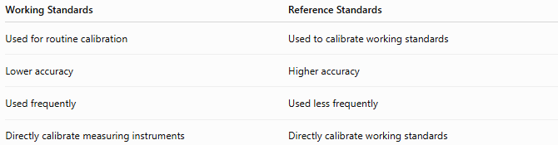
Working Standards | Reference Standards
Used for routine calibration | Used to calibrate working standards
Lower accuracy | Higher accuracy
Used frequently | Used less frequently
Directly calibrate measuring instruments | Directly calibrate working standards

Working Standards vs. Secondary Standards
# Source: AI Source: Provided by: [Data Path: Persons Table -> ID Column: 1, Name_En Column: Motasem Essam] -> From: [ChatGPT] on [7/17/2026]
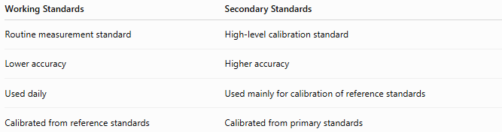
Working Standards | Secondary Standards
Routine measurement standard | High-level calibration standard
Lower accuracy | Higher accuracy
Used daily | Used mainly for calibration of reference standards
Calibrated from reference standards | Calibrated from primary standards

Working Standards vs. Measuring Instruments
# Source: AI Source: Provided by: [Data Path: Persons Table -> ID Column: 1, Name_En Column: Motasem Essam] -> From: [ChatGPT] on [7/17/2026]
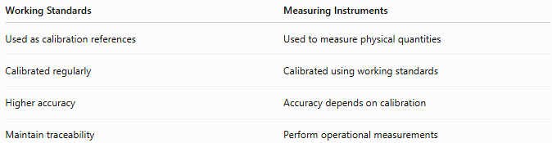
Working Standards | Measuring Instruments
Used as calibration references | Used to measure physical quantities
Calibrated regularly | Calibrated using working standards
Higher accuracy | Accuracy depends on calibration
Maintain traceability | Perform operational measurements

Conclusion
# Source: AI Source: Provided by: [Data Path: Persons Table -> ID Column: 1, Name_En Column: Motasem Essam] -> From: [ChatGPT] on [7/17/2026]
Working Standards are measurement standards used for routine calibration, verification, and everyday measurement activities. Calibrated against reference standards, they provide the practical link between the measurement hierarchy and the instruments used in laboratories, industry, and manufacturing. Although they have the lowest accuracy among formal measurement standards, their regular calibration and traceability ensure reliable, consistent, and accurate measurements in daily operations.

